[19-20-Fuel Efficiency Report #1]
[Report on perceived Car fuel efficiency & satisfaction]
1. Fuel efficiency & satisfaction with Domestic vs. Imported car
2. Fuel Efficiency satisfaction by brand
3. Fuel Efficiency satisfaction by model

Car consumer report 19/20- Fuel Efficiency Report #1;
Domestic hybrids threatening imported cars with high fuel efficiency & satisfaction
- Domestic hybrid fuel efficiency on an equivalent level to imported hybrids’
- Imported cars dominating domestic cars in fuel efficiency and satisfaction
- Domestic hybrids outperforming imported hybrids in fuel efficiency satisfaction

Imported cars were better than their domestic counterparts in perceived fuel efficiency and consumer satisfaction, and the same measures were high for hybrid, diesel, and gas in order. Both domestic and imported hybrids did well on perceived fuel efficiency and consumer satisfaction, with the domestic hybrids indicating a huge improvement in the areas, in particular. The domestic hybrids were similar to the imported hybrids when it comes to perceived fuel efficiency while doing even better than their imported diesel cars in consumer satisfaction. Overall, the imports were rated as very satisfactory, making a big difference in diesel among other things. Consumer satisfaction with imported cars’ fuel efficiency remained intact despite the reduction in the imported car sales volume after fuel efficiency controversies.

The fuel efficiency satisfaction score for imported cars was 72.7 pts., which was largely higher (8.2 pts.) than domestic cars (64.5 pts.), while the satisfaction by fuel type was high for hybrid, diesel and gas in order [Figure 1-1]. Fuel efficiency satisfaction of hybrid cars in both domestic and imported cars exceeded 80 pts., receiving a favorable rates from the consumers What is noticeable was that domestic hybrids earned 80.8 pts and outperformed their imported counterparts (78.0 pts) by not a small margin (2.8 pts), when the imported hybrids were once a king and sensation of fuel efficiency. Domestic diesel cars, however, were unable to close in the big gap (11.0 pts.) with imported diesel cars while domestic gas cars stayed the lowest in the given evaluations.

Regarding compound fuel efficiency that consumers perceive, overall, imported cars (12.7km/ℓ) did better than domestic cars (11.9km/ℓ) on the measure. By fuel type, the perceived compound fuel efficiency was high for hybrid, diesel, and gas in order, with domestic and imported cars performing differently by each of the fuel types. Domestic cars did better (11.5km/ℓ) than imported cars (10.6km/ℓ) in gas fuel efficiency, with the imported cars (13.9km/ℓ) being superior to domestic cars (12.3km/ℓ) in diesel, while both domestic and imported hybrids tied at 16.6km/ℓ when it comes to the fuel type’s efficiency. The results showed that the fuel efficiency of domestic hybrids improved greatly, which then linked to high consumer satisfaction.

[Figure 1-1] Perceived Fuel Efficiency satisfaction [Figure 1-2] Perceived Compound Fuel Efficiency (City driving 55%+Highway 45%)
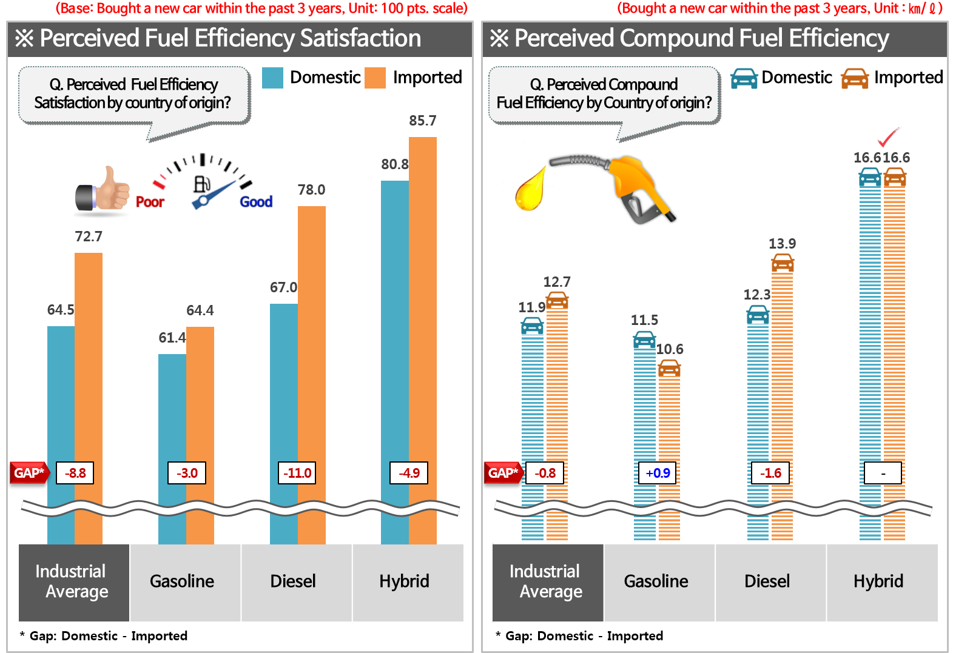
Q. Considering the actual fuel efficiency (City/highway) that you have answered, how satisfied are you with the fuel efficiency of the car in general?
Q. What is the actual kilometers per liter regarding the car’s fuel efficiency?

For imported cars, a bigger portion of vehicles have a larger displacement, then there is among domestic cars in general. For the given reason, seemingly, the imported cars are disadvantageous in terms of fuel efficiency, but the perceived fuel efficiency and satisfaction with the cars were higher than domestic cars. The gap between the imported and domestic cars will be even larger when it comes to the fuel efficiency and consumer satisfaction therewith for the cars of the same car class or the same price. Obviously, the domestic cars remain inferior to imported cars, which will need to be overcome in no time.

Fuel efficiency was one of the driving forces for imported cars, recently, which was predicted hard for domestic cars to beat their imported counterparts upon. However, the recent domestic cars’ remarkable growth in the area showcased a possibility for a new breakthrough. The domestic hybrids not only showed a similar level of fuel efficiency to the imported hybrids’ but also outperformed imported diesel cars in consumers satisfaction, which had not been seen as hardly possible. The domestic hybrids are emerging to counteract the imported hybrids while also sniping at the imported diesel cars at the same time.

The survey results are the part of ConsumerInsight's annual Syndicated Automobile Study (18th as of 2018) that asked those who had bought a new car within the past three years (22,989 respondents) about their cars’ fuel efficiency on city road and highway driving, respectively, and how satisfied they were on a scale of 10 points. The perceived fuel efficiency was converted into driving distance (km) per liter, and consumer satisfaction was into 100 points.

==============================================================
◈ Reference : 「ConsumerInsight」 ‘Annual Syndicated Automobile Study’ Outline
The contents was excerpted and summarized from the results of annual ‘Syndicated Automobile Study’ conducted by ConsumerInsight Inc. on around 100,000 respondents in every July since 2001.

